- SCOPE

The specific purpose for this Work Instruction is to provide details on the imputing of Sanitary Data into the MWQM CSSP Web Tools. If you are already familiar with the CSSP Web Tools, you can jump to section 3.9 for sanitary data imputing instructions.

- REFERENCES

CSSP Web Tools at this address: http://wmon01dtchlebl2/

- PROCEDURE

3.1. Open CSSP Web Tools at this address: http://wmon01dtchlebl2/

3.2 Click on: ‘Latest CSSP Web Tools’

3.3 Click on: Start Using CSSP Web Tools. If you were not logged on previously you will have to log in. Click on ‘Log in ’, Enter your email and password and then click on ‘Start Using CSSP Web Tools’

3.4 First row:

3.4.1 At any point, clicking on the home button on the top left will bring you back to step 3.3

3.4.2 On the top left corner, you have the CSSP Web Tools search bar. This allows you to do a quick search for example: specific sectors or subsector or even a user. If you click on the question mark , you will be given an example of the search commands/tags you should use when using the search bar. These commands will allow you to jump to a specific section very quickly.

3.4.3 On the top right, the profile icon allows you to view and edit your profile: Name and initials, email, telephone number and addresses. You can edit the information by clicking the edit button or you can exit the profile section by clicking the button. When you are in the edit mode, you need to click on the green plus sign in order to update the information you have added or click on the blue check mark in order to update the information you have changed.

3.4.4 The ‘Français or English’ flag allows you to switch the language of the web page.

3.4.5 The log off button on the top right will log you off and take you back to step 3.3.

3.4.6 If you log off and you want to log back on but forgot your password, there is a ‘forgot password’ button that will send you a code by email that you will need to create a new password.

3.4.7 If you are a user with admin capabilities, you will have an additional button on the top right (wrench). This will allow you to search for specific users, erase users or modify their permission levels for different types of information (example: you can set a user as read, write and create for NS but read only for NB). See ‘Admin functionalities of the CSSP Web Tools’ work instruction for more details.

3.5 Second row:

3.5.1 On the right, the 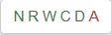 button tells you what permissions you have (in green) and which ones you don’t have (in red). This is a gradual scale. If you have W (write access) then you automatically also have R (read) access. Clicking on the button gives a description of each (i.e.: read, write, create, delete and admin). It also indicated who has ‘Admin’ capabilities (in our case, its Charles Leblanc only for the time being).

3.5.2 Next to the permission button is another profile button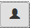. Clicking on this gives you information on who last made modifications/updates in each folder (date and time).

3.6 Third row:

3.6.1 The country tab indicated how many countries are in the Web Tools and by clicking it, will display them below. This is the default tab when you first login into the CSSP Web Tools.

3.6.2 The files tab will allow you to generate reports for the folder/section you are currently in. This is where you will extract data/generate reports for classification, report and sanitary purposes. This functionality will be explained in greater detail in a separate work instruction (See ‘Generating reports with the CSSP Web Tools’).

3.7 Fourth row:

3.7.1 The information button 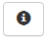 gives you more information about the data/folders that are below it. Clicking it at this point for instance would tell you
how many provinces are in each country, how many municipalities, lift stations, WWTP, subsectors, samples, etc. At any point in time, this button will give you more information on the data that is displayed. Clicking it again, will return you to the previous page/screen.

3.7.2 The edit 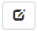 button will allow you to edit or add 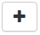 data into the desired folder. For instances, you could add a country at this point or modify the information for a country by clicking on the crayon button . You could also delete a country by clicking on the garbage bin. Clicking on edit in any folder (except the All location tab), will also give you a ‘move’ option 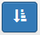 that will appear next to the folder name (Third row). Clicking on this opens up a new window that will allow you to move your current folder or sampling station or sanitary site to a different folder/subsector.

3.7.3 Map

3.7.3.1 The map icon 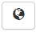 opens up a map of the selected country or province. As you go down into each folder, the map will zoom into the specific region and allow you to view each tab of data, for example; the MWQM sites under Canada/New Brunswick /NB-01-020-001 = Eel Bay and River). The resulting map will display a color coding and letter coding that corresponds to the classification (more on this below). Clicking on the left and right arrows 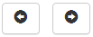next to the map icon will make the map take up more or less space on the screen.

Each Tab will have differing markers to display information. For the ‘MWQM Sites tabs’ the colors for each marker on the map are displayed following these rules: A blue marker represents a general marker that describes a larger area (example: province or subsector). A green marker represents a sampling station that meets approved area standards based on current statistics available (not taking into account the actual classification that includes conditional areas or areas restricted or prohibited because of WWTP or LS, wharves, etc.). A red marker

represents a sampling station that falls under restricted area standards based on current statistics available. Pink markers are sampling stations that have insufficient data to calculate classification statistics with (lower than 10 data sets). They will have a number inside of the marker representing the number of runs for that sampling station. Purple markers are sampling stations that do not meet depuration standards. Gray markers are sampling stations that have no data. Orange markers are general markers to describe a municipality.

The letter inside each marker is displayed following a gradient rule. Samples that are on the lower scale of the classification criteria will have the letter F and samples that are on the higher end of the classification criteria will have the letter A. For example: A green marker with the letter F represents a sampling station who is within approved area standard but who in on the verge of falling into the next classification category negatively i.e.: becoming a red marker/restricted.

Clicking on any marker will give you more information about that specific marker and permit you to either go back up in the folders or if it’s a sampling station, permit you to navigate to that station’s data (it will be displayed on the left hand side).

In other tabs a similar marker scheme is applied to allow you to easily associate the marker to site type.

If you want to easily locate a marker (station, site) on the map, you can click on 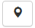 next to the name (on the left side of the screen) and this will place a gray X at the location of that specific marker. Clicking on the 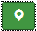 again will remove the X on the map.

3.7.3.2 The map shown is from Google Earth and will have some of the same basic functionalities. You can zoom in and out and use the ‘street view feature’ located at the bottom right of the map. You can also view the map in ‘map’ or ‘satellite mode’ on the top left of the map. You will also find on top of the map window, information like the Lats and Longs of your cursor position and a drop down button  called ‘Map helper’ that include extra functions such as:

- Setup Check Box; when selected, it will show a left and right arrow that allows you to increase or decrease the size

of the map, a hide the map button (clicking on the map icon in the tab section will also close the map). There is also a Marker size box that allows you to increase the characters within your map marker. The greater the number the more description in your map marker.

- The edit check box that allows you to edit 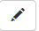 markers or polygons by dragging markers to different locations or changing the boundaries of a subsector by clicking on them and dragging the dots(in a line segment there will be a dot at each end and one in the middle). You must click on the  save icon to save the changes you’ve made or the cancel or undo icon to cancel your changes. This is a quick way of changing the positions of makers (sampling stations or sites) that are wrongly positioned.

- Legend Check Box; will describe the different icons on the map.

- Browse check box that will allow you to navigate back up in the folders (from subsector to a sector for example) or to navigate to other tabs (Files or Municipality tab for example)

All these functionalities in the fourth row (info, edit, map) can be found in any sub folder that you click. Re-clicking the edit, info or map button will take you back to the original folder you were in.

3.8 All locations: Clicking on Canada will open up the different provinces available as well as display the amount of data there is for each province (displayed in a gray circle next to the name of each province). A more detailed description can be presented by clicking the information button.

3.9 Managing Sanitary Data in the Pollution Source Sites tab of CSSP Web Tools:

3.9.1 Clicking on the Sectors within the Areas tab will bring you to the Subsector of your choice. Within a sub-sector are 8 tabs and this document will deal with the Pollution Source Sites tab.

3.9.2 Functionality: The Pollution Source Sites tab will display all the pollution source sites (Sanitary) available for that Subsector (gray markers on map), when the map button is selected (Figure 1). In addition you will see colored markers that indicate infrastructure from the Municipalities tab. These include Lift Stations (LS- maroon markers on map), Waste Water Treatment Plants (WWTP-red markers on map) and their respective OF – Outfalls (tan markers on map).

The infrastructure components will not be entered into the Pollution Source Sites tab but will be documented only under the Municipalities tab. This ensures that data is entered in only one location. NOTE: Under our former system, various provinces included the Pollution Source Sites and infrastructure sites together. When the data was uploaded into Web Tools both sets of data appeared under the Pollution Source Sites tab. These will be removed over time and entered into the Municipalities tab. The location and information on the infrastructure components will be linked to the Pollution Source Sites tab and will be downloaded to generated reports and maps for field survey purposes. All new infrastructure or modifications to existing infrastructure components are to be entered under the Municipalities tab (see the ‘Municipalities tab in CSSP Web Tools’ work instruction).

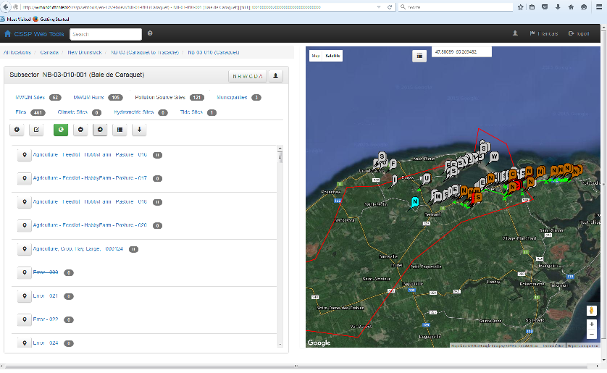
Figure 1: Pollution Source Sites tab

3.9.3 Within the Pollution Source Sites Tab all the active sites will be listed. ‘Inactive’ sites will have a horizontal line thru the center of the site name and can be views by selecting the ‘all sites’ toggle button.

Originally each site was identified by a “feature”, such as a culvert, water course or fish plant and, followed by a site number. The new system will identify a site by a label that describes the major land use type, (for example – agriculture or forestry or industry), then the site number. A site that has been uploaded from SanApps into Web Tools will have a three digit number (example – Agriculture 025 or Error 025). A site that has been edited using Web Tools or a new site would have a six digit number in the following format (example - Agriculture, Crop 000028). Please note that a site labelled “Error” occurs if Web Tools does not have sufficient information to classify a site. This site must be modified using the edit button as per section 3.9.5. To sort the sites by most recently modified click on the down arrow toggle button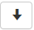.

3.9.4 In the Pollution Source Sites tab you can modify a site by clicking the edit button. This will put an edit 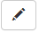 button and delete button beside each site and also put an add button on the toggle button bar. At this point you can create a new site (section 3.9.4.3), edit an existing site by adjusting the coordinates or address; delete a site or make a site inactive.

3.9.4.1 To edit a site, click the edit button to the left of a site. This opens up a window showing the information you can edit. The Address button is used to add an address to a site (Figure 2). Enter the Latitude and Longitude coordinates and click on the ‘Get civic address from Google’ button. The closest address to the coordinates will be auto populated in the header. Using this information, fill in the boxes below.
You will also be asked to choose the Country, Province and Municipality. If the municipality your site is located in does not have a wastewater treatment system then it may not be on the municipality list. To add a municipality to the system, move out of the Sanitary Tab and into the Municipality Tab. Once here click the edit button and the
Add form will appear. You only need to enter name and coordinates. Select coordinates that are centered in the sub sector. Click add and the new municipality is added.

You can put in a more exact civic number and street than what is provide by google. Remember that you must click the modify button to save changes.

At the bottom of this window are two question to answer. If the site is not active remove the check from the ‘Is Active’ box. This will result in the request for a reason why it is inactive. Check the appropriate choice.

Making a site inactive will hold this site as a historical record. This site can be made active again by selecting the ‘Is Active’ box.

3.9.4.2 Deleting a site will completely remove the entry from the database; hence, this is used only if you made a mistake. Remember that you must click the modify button to save changes.

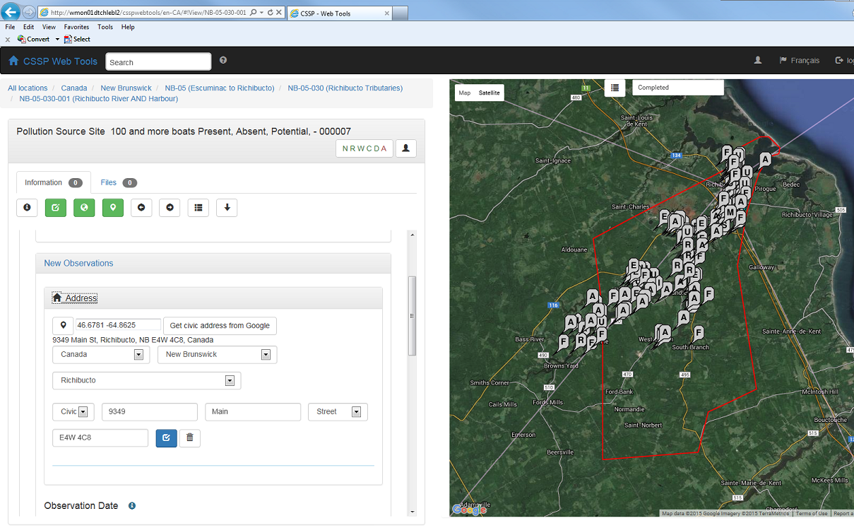
Figure 2: Address

3.9.4.3 New sites are created by clicking the add button (Figure 3).Start by adding a location (Latitude, Longitude). Indicate if the site is Active using the check box; indicate if the site is Point Source using the subsequent check box. Select the Add button.

The new site will appear as “Error – 0000###” somewhere in the list. To put this site at the top of the list click the down arrow button.

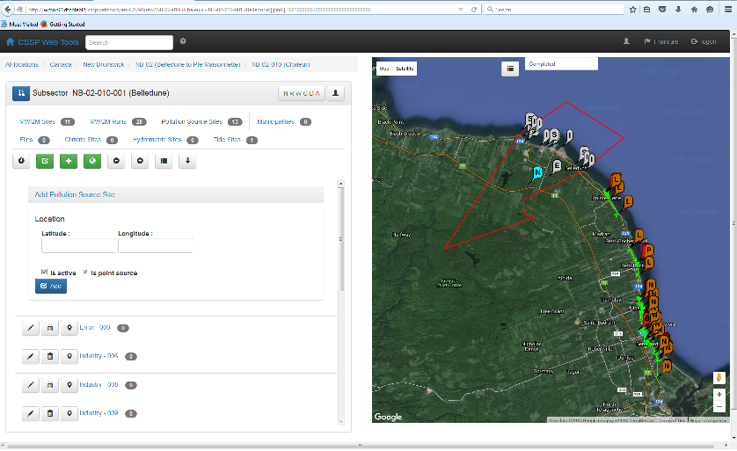
Figure 3: New Observations

This new site is labelled ‘Error’ because you have not added any observation data. To edit the observation data select the site name. The new window that opens will have two tabs (Information and Files). See section 3.9.6 for File tab. The Information tab will show you the date of creation and inspectors name. You can change the date but this will also update the inspector’s name to that of the account you are using. You can also delete this observation or copy it. Remember that if it is a new site, the observation data does not exist and so can’t be deleted. If you want to delete you must go back to the site data and delete this site.

Each Observation is composed of one or more Issues. All observations must have at least one issue and this first issue cannot be deleted. You would have to delete the site to remove it. To enter an observation click on the edit button and then on Issue # 1 under Edit Issues and complete the selections provided. To add another issue, select the add issue button and the new issue box will appear. Ensure you select the correct numbered issue before editing since you could be adjusting another issue since that box would have been highlighted previously.

Remember that the Issue selection is a hierarchy of descriptions, intended for users of all levels. It is generic; for example – general distance to shore (this can be calculated on Google Earth); slope – flat, moderate, steep; etc. As you work through the listing, continue to select the best answer. This method should create a uniform description of Issue and allow quick translation and reporting in the future. Also, this system will be used across the country so there is a question about whether the observation is on land or on the water. In BC there are many water based sites such as floating communities; for us on the east coast, this would be used for barges anchored close to shore.

Also keep in mind that we are trying to identify what is the fecal source and how it interacts with growing waters. Hence one observation can have multiple issues associated with it, such as a farm;
Issue 1 – Agriculture/barn/animals/runoff…
Issue 2; Agriculture/building/residential/ 1 people/sewage/drainagefield….; Issue 3 – Agriculture/crop/food/runoff/vegetated surface..
Issue 4 – Agriculture/pasture/active/large/manure pile/runoff….

At the end of each issue you must define the Status of the Issue as a pollutant source (Definite, Non Polluting or Potential) and finally, identify the Risk to Pollute (Low, Moderate or High). Remember to save the information using the check box  button.

3.9.5 Adding site observations and editing site observations

3.9.5.1 To edit an observation of an already existing site, select the site name. This brings you to the observation page/information tab where you can see the entries. Begin by selecting the edit button. This opens the last observation for editing. You can only edit the last observation. Remember to click on save button if you modify the date or issues of an already existing observation. Do not click the COPY button if you are only editing the most current observation (i.e., no change in the observation date). The COPY button is used for adding a new observation to an already existing site.

3.9.5.2 If you want to add a new observation to an already existing site; select the site name. This brings you to the observation page/information tab where you can see the entries. Begin by selecting the edit button. Next to the date and delete button you will see a copy button 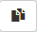. Selecting the copy function will produce a window that notes the file is copied (‘Success – Copied’). The copied file is shown with today’s date and will be ready for editing (the previous observation will have been pushed to the bottom of the screen). Remember that you have to change the date to reflect the observation date and when you do this

you must select Modify. This updates the date and puts you as the inspector. Continue to edit the Issues to reflect the new information as per section 3.9.4.3.

3.9.6 Photos can be added to the observation by selecting the File tab. Under the Files tab, click on the edit button and the add button. Choose your file type (Picture) under the Upload File drop down box. Add a file description. Under File Name, click the Browse button to search for your file to be uploaded.

If necessary, change the file name in order to accurately describe the observation. This can be done by removing the check mark under ‘Keep file name’. You will then be able to rename your file in the box “Save as file name no extension”. Use the check box “From Water” if the observation was taken during a boat survey. Click on the Upload button to save the file (Figure 4).

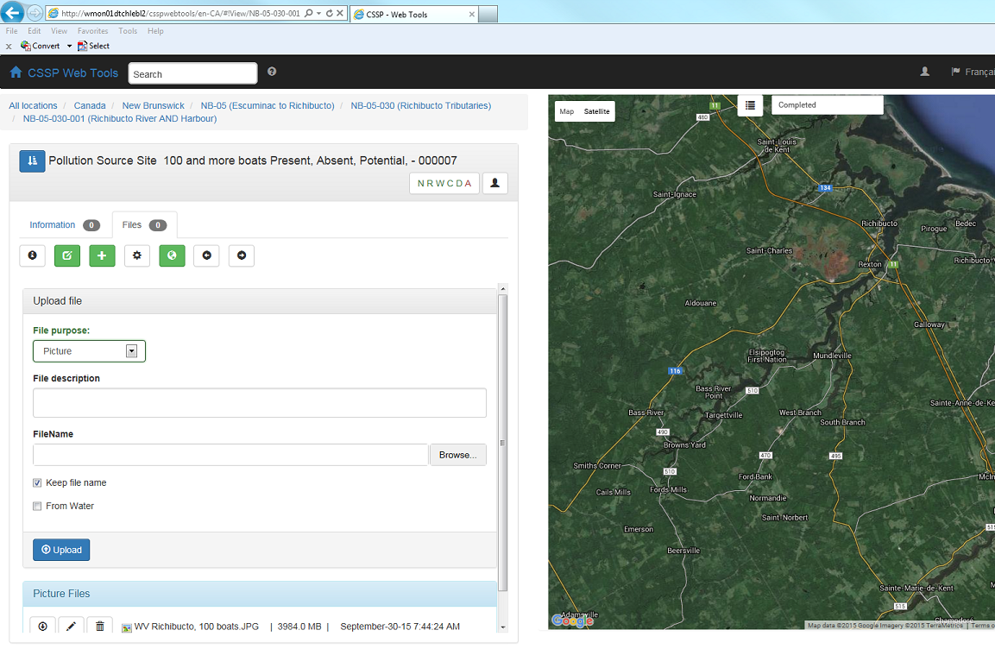
Figure 4: Pictures

3.10 Generating Reports for Pollution Source Data:

3.10.1 Under the Files tab you can added information or generate reports and maps. Clicking on the Show Generate Report button will show a listing of available products. Select your choice and click the Generate
Button (Figure 5).

Once the file is generated it appears in the listing at the bottom of the window. To download a file click on the edit button at the buttons bar at the top. This will add a down-arrow button beside each file. Clicking this button will download the report. KMZ files will open in Google Earth. Please note that this file will have all the information for the subsector. You can then select the appropriate data from the listing in Google Earth. In the future you will be able to create personal templates for reporting.

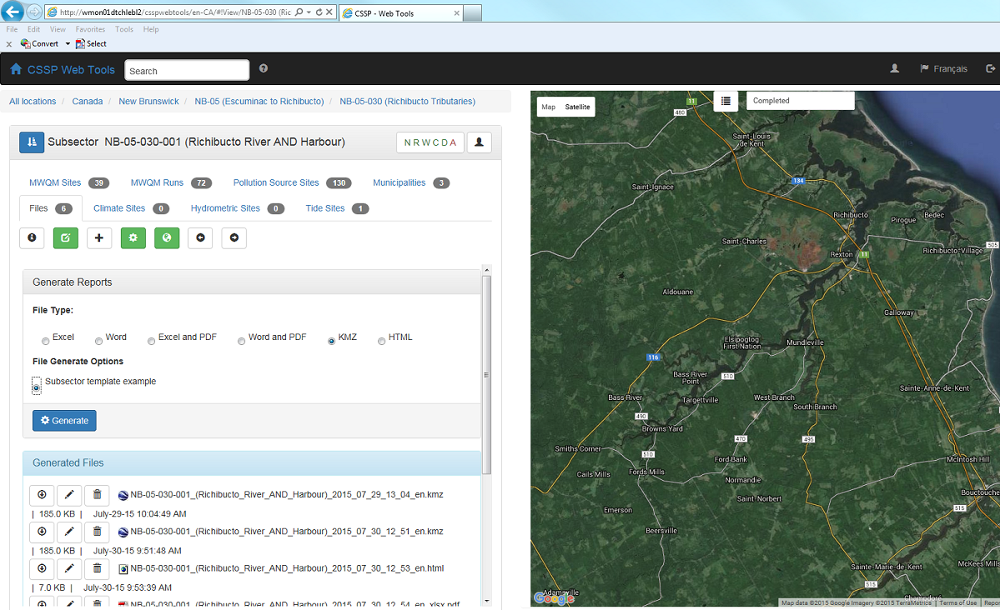
Figure 5: Generating Reports for Sanitary Data

3.11 General Notes Concerning Groupings for a Site

Below is a short list of general notes concerning groupings for a site:

- Six major land use types – select the one which seems to best describe the major of land use.

- Agriculture – a manure pile is ordered under pasture.

- Under animals we decided that the species of bird or animal is not a documented concern, just the size of the creature (i.e. medium size birds).

- Forestry – if a site is within trees, they have been harvested therefore this site would be classed as Regrowth.

-Urban now includes storm water, surface runoff and dump station; all others infrastructure goes under the municipality tab.

If you come across a site that doesn’t fit, select the best fit and then we can modify the groupings to add your situation.

- MAINTENANCE

For any additional troubleshooting help (errors or bugs), please contact Charles LeBlanc (Charles.leblanc2@canada.ca). For general questions, contact your local CSSP working group committee member.

